***SportZ***

CHANGE MANAGEMENT PLAN

Version 1.0

Prepared by Team SportZ

**Lin Zixing**

**Fabian Wong**

**Chia Songcheng**

**Lim Sheng Zhe**

**Chew Poshi**

**Chee Zi Hoe**

**Hermes Lim HongJun**

28 March 2022

VERSION HISTORY

|  |  |  |  |  |  |
| --- | --- | --- | --- | --- | --- |
| **Version #** | **Implemented**  **By** | **Revision**  **Date** | **Approved**  **By** | **Approval**  **Date** | **Reason** |
| 1.0 | Chew Poshi | 03/24/2022 | Lim Sheng Zhe | 03/28/2022 | Initial Change  Management Plan |
|  |  |  |  |  |  |
|  |  |  |  |  |  |

**TABLE OF CONTENTS**

**1 INTRODUCTION** **5**

1.1 Purpose of The Change Management Plan 5

**2 CHANGE MANAGEMENT PROCESS** **5**

2.1 Change Request Process Flow Requirements 5

2.2 Change Request Form and Change Management Log 6

2.3 Evaluating and Authorizing Change Requests 6

2.3.1 Change Control Board 7

**3 RESPONSIBILITIES** **7**

**APPENDIX A: CHANGE MANAGEMENT PLAN APPROVAL** **8**

**APPENDIX B: REFERENCES** **9**

**APPENDIX C: KEY TERMS** **10**

**APPENDIX D: CHANGE REQUEST FORM EXAMPLE** **11**

**APPENDIX E: CHANGE MANAGEMENT LOG TEMPLATE** **12**

# INTRODUCTION

## PURPOSE OF THE CHANGE MANAGEMENT PLAN

The Change Management Plan documents and tracks the necessary information required to effectively manage project change from project inception to delivery.

The Change Management Plan is created during the Planning Phase of the project. Its intended audience is the project manager, project team, project sponsor and any senior leaders whose support is needed to carry out the plan.

# CHANGE MANAGEMENT PROCESS

The Change Management process establishes an orderly and effective procedure for tracking the submission, coordination, review, evaluation, categorization, and approval for release of all changes to the project’s baselines.

## CHANGE REQUEST PROCESS FLOW REQUIREMENTS

|  |  |
| --- | --- |
| **Step** | **Description** |
| Generate  Change  Request (CR) | A submitter completes a CR Form and sends the completed form to the Change Manager |
| Log CR Status | The Change Manager enters the CR into the CR Log. The CR’s status is updated throughout the CR process as needed. |
| Evaluate CR | Project personnel review the CR and provide an estimated level of effort to process, and develop a proposed solution for the suggested change |
| Authorize | Approval to move forward with incorporating the suggested change into the project/product |
| Implement | If approved, make the necessary adjustments to carry out the requested change and communicate CR status to the submitter and other stakeholders |

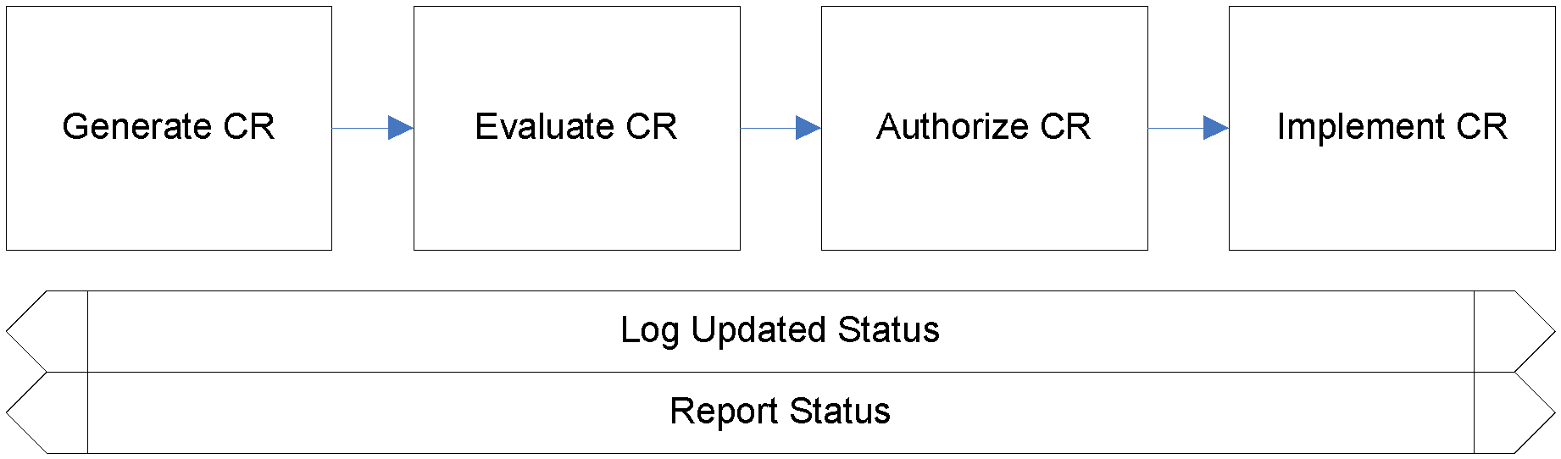

## CHANGE REQUEST FORM AND CHANGE MANAGEMENT LOG

|  |  |
| --- | --- |
| **Element** | **Description** |
| Date | The date the CR was created |
| CR ID | Assigned by the Change Manager |
| Title | A brief description of the change request |
| Description | Description of the desired change, the impact, or benefits of a change should also be described |
| Submitter | Name of the person completing the CR Form and who can answer questions regarding the suggested change |
| Phone | Phone number of the submitter |
| E-Mail | Email of the submitter |
| Product | The product that the suggested change is for |
| Version | The product version that the suggested change is for |
| Priority | A code that provides a recommended categorization of the urgency of the requested change (High, Medium, Low) |

## EVALUATING AND AUTHORIZING CHANGE REQUESTS

Change requests are evaluated using the following priority criteria:

|  |  |
| --- | --- |
| **Priority** | **Description** |
| Critical | This issue results in the unusability of the product due to its basic functions not being able to run. This CR will impact all users and has to be resolved immediately. |
| High | Any change that impacts important product components or systems structure, may require outage. This includes the need to overhaul project requirements and structure. This CR need to be resolve with immediate attention as it will impact major users |
| Medium | CR was made by a client and is mandatory. CR causes little to no impact on the integrity and performance of the system and should be addressed accordingly. |
| Low | Minor issues such as minor bug issues , cosmetic changes , and client feature requests that can be rejected. CR causes little to no impact on the integrity and performance of the system and should be addressed accordingly. |
| Insignificant | Small-scale feature made by client. This CR does not impact the system to any form. |

Change requests are evaluated and assigned one or more of the following change types:

|  |  |
| --- | --- |
| **Type** | **Description** |
| Scope | Change affecting scope |
| Time | Change affecting time |
| Duration | Change affecting duration |
| Cost | Change affecting cost |
| Resources | Change affecting resources |
| Deliverables | Change affecting deliverables |
| Product | Change affecting product |
| Processes | Change affecting process |
| Quality | Change affecting quality |
| Availability | Change affecting the uptime of the application to the public domain |
| Reliability | Change affecting the integrity of the system |
| Scalability | Change affecting future enhancements |
| Maintainability | Change affecting efficiency and performance of operational status restoration |

Change requests are evaluated and assigned one of the following status types:

|  |  |
| --- | --- |
| **Status** | **Description** |
| Open | Entered/Open but not yet approved or assigned |
| Work in Progress | CR approved, assigned, and work is progressing |
| In Review | CR work is completed and in final review prior to testing |
| Testing | CR work has been reviewed and is being tested |
| Closed | CR work is complete, has passed all tests, and updates have been released. |
| On Hold | CR approved, assigned, and work is put on hold |
| Rejected | CR is rejected |

### Change Control Board

|  |  |  |  |  |
| --- | --- | --- | --- | --- |
| **Role** | **Name** | **Contact** |  | **Description** |
| Project  Manager | Lin Zixing | 90691707 | ● | Oversees project progress |
|  |  |  | ● | approves and executes project plan |
|  |  |  | ● | Distribute task to team |
|  |  |  | ● | Report to team on progression of project |
|  |  |  | ● | Manage and motivate team members |
|  |  |  | ● | Represents team to outside world |
|  |  |  | ● | Makes decisions on deadline for tasks |
| Risk Manager | Hermes Lim HongJun | 96387628 | ● | Conduct bi-weekly risk assessment meetings with the Risk management team to provide updates on existing risk progress. |
|  |  |  | ● | Ensure all risk project plans changes are up to date. |
|  |  |  | ● | Brainstorm with the Risk management team on  strategies to reduce and eliminate risk involved in the project. |
| Client representative | Chia Songcheng & Lim Sheng Zhe | 83157488 | ● | Represents client and present client request on requested changes or additions. |
|  |  |  | ● | Understand the solution provided and present it to the client for feedback and approval. |
| QA Manager | Chee Zi Hoe | 92572848 | ● | Oversees Overall product and process quality |
|  |  |  | ● | Ensures all functional and non-functional requirements are met |
|  |  |  | ● | Establish baseline for testing |
|  |  |  | ● | Develops, manages, and executes all phases of quality assurance testing, including analysis of product requirements to produce test requirements |

|  |  |  |  |  |  |
| --- | --- | --- | --- | --- | --- |
|  |  |  |  | ● | Recording, analyzing, and distributing statistical information |
|  |  |  |  | ● | Supervising QA Engineer |
|  |  |  |  | ● | Oversee the test procedures made by QA engineer |
| Tech Lead | Fabian Wong | 87256323 | ● | Overall Technical Lead |
|  |  |  |  | ● | Responsible for Product Release |
|  |  |  |  | ● | Coordinate team’s schedule |
|  |  |  |  | ● | Ensure Effective  Communication between team members |
|  |  |  |  | ● | Establish stimulated software development standards |
|  |  |  |  | ● | Establish best practices for delivery of high-quality software |
|  |  |  |  | ● | Assess the change request and produce an estimated timeframe |
|  |  |  |  | ● | Ensure Change Requests are completed within the agreed timeframe. |

# RESPONSIBILITIES

|  |  |  |  |  |
| --- | --- | --- | --- | --- |
| **Role** | **Name** | **Contact** |  | **Description** |
| Project  Manager | Lin Zixing | 90691707 | ● | Activity and resource planning |
|  |  |  | ● | Controlling time  management by preparing work breakdown structure |
|  |  |  | ● | Ensure project schedules and deliverables are met |
|  |  |  | ● | cost and risk estimation |
|  |  |  | ● | Monitor progress and report to Change Control Board |
|  |  |  | ● | Manage report and necessary documentation |
| Change Manager | Chia Songcheng | 83157488 | ● | Identify and highlight changes to be made |
|  |  |  | ● | Prepare and update the  Change Management  Plan for traceability verification |
|  |  |  | ● | Assess the cost and urgency of the change request |
|  |  |  | ● | Apply strategies to support adoption of change required. |
| Change  Analyst | Lim Sheng Zhe | 84672875 | ● | Analyze the Change Request and predict impact of the change |
|  |  |  | ● | Update change requirement |
|  |  |  | ● | Implement change management activities |
|  |  |  | ● | Participate in evaluating impact of proposed change |

|  |  |  |  |  |  |
| --- | --- | --- | --- | --- | --- |
|  | Communication Manager | Chew Poshi | 88654911 | ● | Oversee all internal and external communication of the project |
|  |  |  |  | ● | Communicate and  feedback to clients on change related issues and technical details |

# Appendix A: Change Management Plan Approval

The undersigned acknowledge they have reviewed the **Sportz Change Management Plan** and agree with the approach it presents. Changes to this **Change Management Plan** will be coordinated with and approved by the undersigned or their designated representatives.

|  |  |  |  |
| --- | --- | --- | --- |
| Signature: |  | Date: | 31/03/2022 |
| Print Name: | Lin Zixing |  |  |
| Title: | Project Manager |  |  |
| Role: | Oversees the management of the team |  |  |

|  |  |  |  |
| --- | --- | --- | --- |
| Signature: |  | Date: | 31/03/2022 |
| Print Name: | Fabian Wong |  |  |
| Title: | Tech Lead |  |  |
| Role: | Lead team of software developers |  |  |

|  |  |  |  |
| --- | --- | --- | --- |
| Signature: |  | Date: | 31/03/2022 |
| Print Name: | Chia Songcheng |  |  |
| Title: | Change Manager |  |  |
| Role: | Monitors and supervises the process of operational changes |  |  |

# Appendix B: References

The following table summarizes the documents referenced in this document.

|  |  |  |  |
| --- | --- | --- | --- |
| **Document**  **Name and Version** | **Description** |  | **Location** |
| SportZ_Change  _Management_  Plan_v1.0.doc | Sportz Change  Management Plan  Document | In wiki |  |

# Appendix C: Key Terms

The following table provides definitions for terms relevant to this document.

|  |  |
| --- | --- |
| **Term** | **Definition** |
| Baselines | An intermediate status of work results that record/save and approve at certain points in time. It serves to provide a fixed reference point for change management. |
| Change  Control Board | A committee that evaluates and prioritizes change requests in the context of projects. |
| Change  Request (CR) | A formal proposal for an alteration to some system. Such requests typically originated from bugs / system enhancement / development of other systems / changes in underlying structure and or standards. |
| Change  Request  Form (CRF) | A form that is used to request a change in the project. |
| Work  Breakdown  Structure  (WBS) | A project management tool that breaks down the deliverables of the project into smaller components. It helps to orgainzes the team’s work into manageable sections and accomplish a large project within a certain timeframe. |

# Appendix D: Change Request Form Example

The example Change Request From attached below can be used to submit changes during the life of the project.

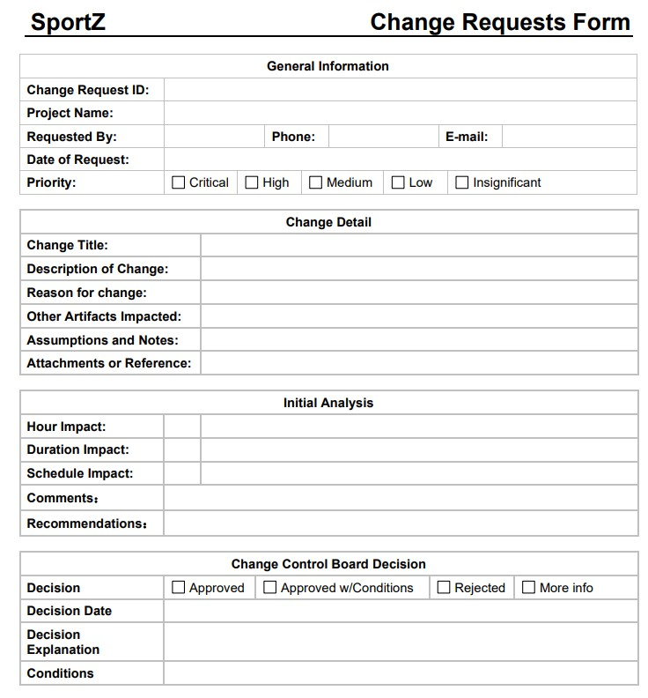

# Appendix E: Change Management Log Template

The detailed Change Management Log template attached below can be used to track and manage requested changes during the life of the project.

